A Tactile Shape Display Using RC Servomotors

【Summary】：

Can users recognize 3D features only from electrical vibration feedback without any visual information.

【Device】：

The Feelscreen development kit was used as an electrostatic friction display, which included an electrostatic film covering a commercial tablet (Google Nexus 7).

Rub-pen because you find that the stylus and bare fingers are very similar in electrical vibration.

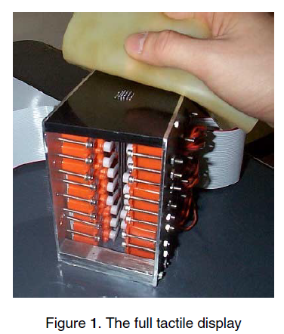

【Conclusion】：

Research shows that users cannot naturally recognize electrical vibrations. 3D shaped graphics have no visual cues, but they can have acceptable performance if given clear guidance.